Greatest Premier League goal scorers of all time

The English Premier League has existed since 1992. Since that time 20 players have managed to join what is called the Ton up Club for scoring 100 or more goals in the Premiership during their football career.

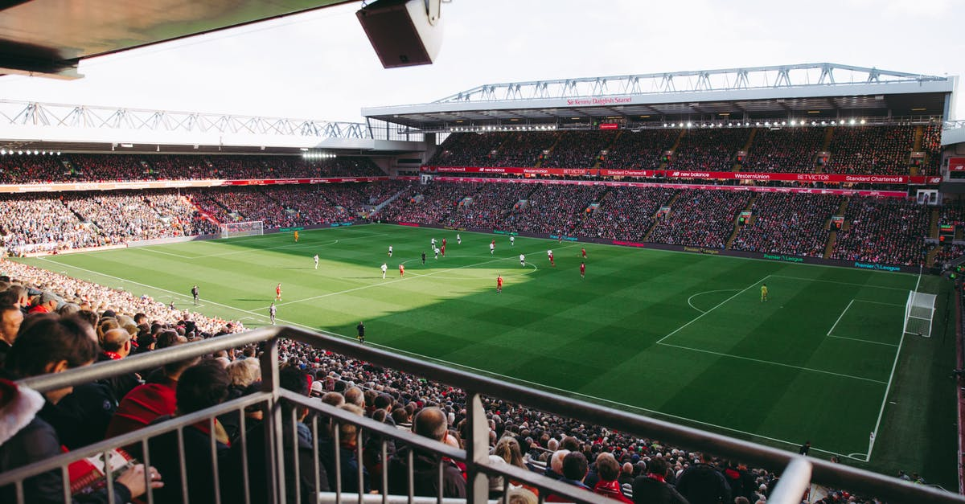With the top two scorers all-time separated by 73 tallies, it is a mountain of goal scoring giants to overtake in order to reach the pinnacle of the English game's elite.

Midfielders as well as strikers have managed the feat and no one can deny that some players could have done more if not for road bumps in their careers.

Players and goals

This table shows the players with the highest goals tally in the English Premier League:

|  |  |
| --- | --- |
| Player | Goals |
| Alan Shearer | 260 |
| Andy Cole | 187 |
| Thierry Henry | 174 |
| Robbie Fowler | 163 |
| Les Ferdinand | 149 |
| Michael Owen | 149 |
| Teddy Sherringham | 147 |
| Frank Lampard | 139 |
| Jimmy Floyd Hasselbaink | 127 |
| Dwight Yorke | 123 |
| Robbie Keane | 123 |
| Nicolas Anelka | 123 |
| Wayne Rooney | 119 |
| Emile Heskey | 117 |
| Ian Wright | 113 |
| Dion Dublin | 111 |
| Ryan Giggs | 110 |
| Paul Scholes | 102 |
| Matthew Le Tissier | 101 |

1. Alan Shearer – 260 Premier League Goals

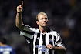Alan Shearer, OBE, was born on 13th August 1970. Having started his career at Southampton, he went on to become one of the most prolific scorers of all time with Blackburn and his beloved Newcastle.

Great in the air, predatory from close range and deadly from distance, Shearer was at one time the complete striker.

After the first ten years of the Premier League, Shearer was named as the outstanding player of the decade. He is also listed in the FIFA 100 greatest living footballers.

Alan Shearer is currently a soccer pundit working for Match of the Day

1. Andy Cole – 187 Premier League Goals

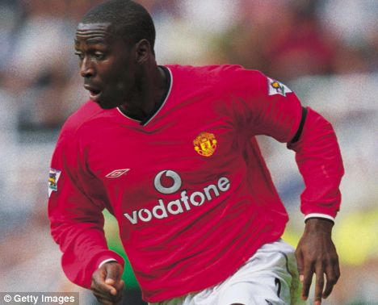Andy Cole was born on 15th October 1971. He began his career with Arsenal, but played just one game before moving to Bristol City. His goal scoring exploits for The Robins caught the attention of Kevin Keegan at Newcastle, who signed the striker in 1993. Cole partnered Peter Beardsley, won the First Division and continued scoring in the Premier League for the following two seasons.

He was sold controversially to Manchester United in 1995; where he went on to achieve huge success. He was the top scorer in Europe for United in the treble winning season of 1998-99, a season in which he and Dwight Yorke contributed 53 goals between them overall.

1. Thierry Henry – 174 Premier League Goals

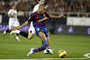Thierry Henry was born on 17th August 1977. He moved to Arsenal after a relatively successful career in France and Italy, but was regarded by many as an overrated wide player. Arsene Wenger converted Henry to be a striker and the rest, as they say, is history.

Henry’s goals won the Premier League twice for Arsenal, including the 30 league goals he scored as Arsenal’s famous Invincibles went the entire 2003/4 season unbeaten. Henry was twice awarded the PFA Players Player of the Year award, and also won the Football Writers Player of the Year award on two occasions.

For France, Henry scored 51 goals in 123 appearances and has World Cup and European Championship winner’s medals.

1. Robbie Fowler – 163 Premier League Goals

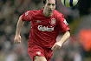Robbie Fowler was born on 9th April 1975. He grew up in Toxteth, a rough area of Liverpool, and went on to become one of the best players ever to represent the Reds. In 1995 and 1996 he was awarded the PFA Young Player of the Year award.

Renowned for his natural finishing ability, in 1994 Fowler scored three times in 4 minutes, 33 seconds against Arsenal, still the fastest hat-trick in Premier League history.

5a. Les Ferdinand – 149 Premier League Goals

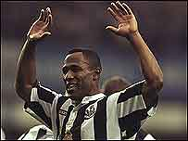Les Ferdinand, MBE, was born on 8th December 1966. He began his career scoring goals galore for lower league Hayes, and continued to do so wherever he went.

His first big move was to top flight Queens Park Rangers, where he spent eight years banging in goals from 1987 to 1995 before earning a high profile move to Newcastle United. On Tyneside, Ferdinand developed a frightening strike partnership with Alan Shearer.

5b. Michael Owen – 149 Premier League Goals

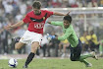Michael James Owen was born on 14th December, 1979 in Chester, England. He is the son of a former forward of the 1970s, Terry Owen.

Michael Owen began his youth career in Liverpool in 1991. He progressed through the ranks and on his debut with the senior team in 1997, he scored. In his first full season in the English Premier League, he finished the season as the joint top-scorer with 18 goals.

Liverpool won a cup treble of the UEFA Cup, FA Cup and the Football League Cup and Owen was awarded the Ballon d’Or. He went on to score 118 goals for the Reds in the Premier League.

Alan Shearer's record at the top could be one of the hardest to ever beat, and currently, only one member of the club truly has a chance of catching him.